CMYK Color Model

📘 Definition
# Source: AI Source: Provided by: [Data Path: Persons Table -> ID Column: 1, Name_En Column: Motasem Essam] -> From: [ChatGPT] on [5/2/2026]
The CMYK color model is a system used in printing that creates colors using four inks:
- C = Cyan
- M = Magenta
- Y = Yellow
- K = Key (Black)
It works by mixing inks on white paper (a subtractive color model)—the more ink you add, the darker the color becomes.

🎨 How CMYK works
# Source: AI Source: Provided by: [Data Path: Persons Table -> ID Column: 1, Name_En Column: Motasem Essam] -> From: [ChatGPT] on [5/2/2026]

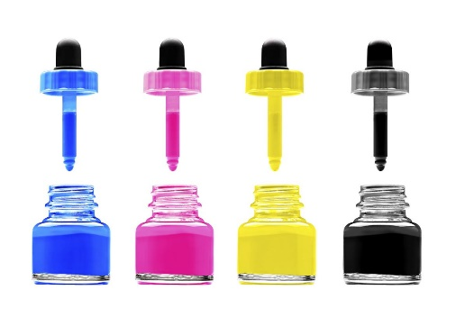
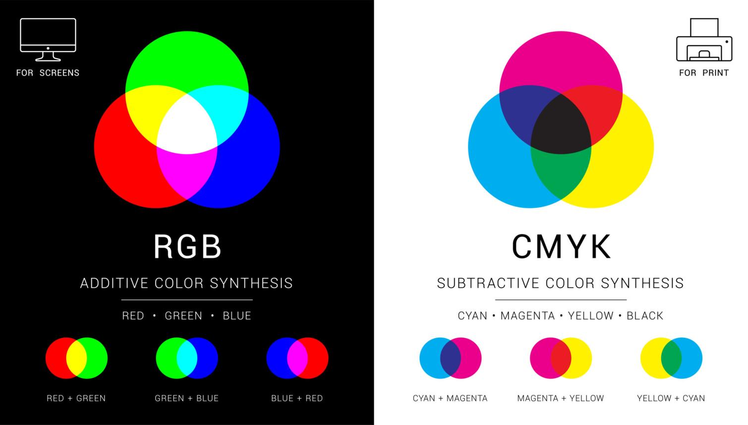
- Starts with white paper
- Inks absorb light and reduce brightness
- Combining CMY creates many colors, but black (K) improves depth and contrast

🧠 Examples of CMYK values
# Source: AI Source: Provided by: [Data Path: Persons Table -> ID Column: 1, Name_En Column: Motasem Essam] -> From: [ChatGPT] on [5/2/2026]
CMYK colors are written like this:
CMYK(C%, M%, Y%, K%) where each value is from 0% to 100%
Here are simple examples:
- Black → CMYK(0%, 0%, 0%, 100%)
- White (paper) → CMYK(0%, 0%, 0%, 0%)
- Cyan → CMYK(100%, 0%, 0%, 0%)
- Magenta → CMYK(0%, 100%, 0%, 0%)
- Yellow → CMYK(0%, 0%, 100%, 0%)

🎯 Mixed color examples
# Source: AI Source: Provided by: [Data Path: Persons Table -> ID Column: 1, Name_En Column: Motasem Essam] -> From: [ChatGPT] on [5/2/2026]
- Red → CMYK(0%, 100%, 100%, 0%)
- Green → CMYK(100%, 0%, 100%, 0%)
- Blue → CMYK(100%, 100%, 0%, 0%)
- Orange → CMYK(0%, 50%, 100%, 0%)
- Dark Gray → CMYK(0%, 0%, 0%, 70%)

🖨️ Where CMYK is used
# Source: AI Source: Provided by: [Data Path: Persons Table -> ID Column: 1, Name_En Column: Motasem Essam] -> From: [ChatGPT] on [5/2/2026]
- Printing books and magazines
- Posters and flyers
- Packaging and labels
- Newspapers

🚀 In short:
# Source: AI Source: Provided by: [Data Path: Persons Table -> ID Column: 1, Name_En Column: Motasem Essam] -> From: [ChatGPT] on [5/2/2026]
CMYK color model = a printing system that creates colors using Cyan, Magenta, Yellow, and Black inks.

